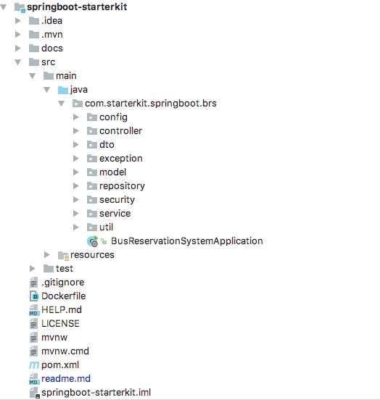

Models & DTOS:

The various models of the application are organized under the model package, their DTOs(data transfer objects) are present under the DTO package.

Models:

1. Resource
2. Project
3. User

DTOs let us transfer only the data that we need to share with the user interface and not the entire model object that we may have aggregated using several sub-objects and persisted in the database.

Service & DAOs:

The data access objects are present in the repository package, helping the service layer to persist and retrieve the data from DB.

The service layer is defined the service package

UserService: for user to signup, change password, and login

TemplateService: for user to add column and customize the formula

Service layer never accepts a model as input and never ever returns one either.

The controller will interact with the service layer to get a job done whenever it receives a request

Controllers bind everything together right from the moment a request is intercepted till the response is prepared and sent back.

The controller is present in the controller package.

@Service

@Controller

@Repository

@